1. **Oauth**: **Open** **Authorization**.
2. Tweeter, Facebook, Google, Github follow Oauth Framework.
3. Why Oauth is so famous?  
   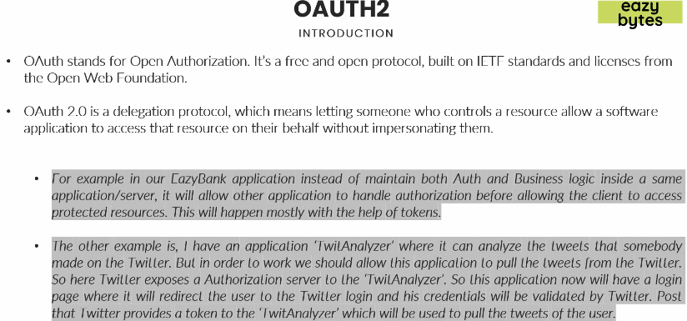
   1. The reason is this is delegation protocol.
   2. It means it will delegate the authentication and authorization of a user to something else so that we don’t have to tie up both authentication and authorization with the business logic that we maintain.
   3. Let’s try by two examples.
      1. **Example** 01:
         1. We have EasyBank app where we have three different applications (Loans, Cards, Accounts)
         2. So, instead of having authentication and authorization in all these 3 app,  
            We can have a single authorization server which will handle authenticating the user credentials and issuing a token.
         3. Now, when a user tries to access any resource from any of those 3 apps, the resource server will ask for Oauth token.
         4. If the user accessing resource server doesn’t have Oauth token, the resource server will redirect the user to the Oauth server to login there and get a token.
      2. **Example** 02:
         1. The scenario where we have 3rd party application involved like **Tweeter Analyser** to analyze my tweets.
         2. In this scenario, I don’t want to expose my credentials to **Tweeter Analyser App**.
         3. So, whenever I want to login in the **Tweeter Analyser App**, it will delegate login functionality to the Tweeter App by saying “Ok this user is a Twitter user and I don’t want to take his credentials to perform authentication and authorization operations. I will redirect to Twitter Authorization Server where he can enter his login credentials and I will get a token from the Twitter, which I can use for all further communications to get the resources about the user”.
4. So, Oauth basically decouples the authentication and authorization functionalities to a another server called Authorization Server and at the same time it will encourage us to maintain the protected resources separately on Resource Server.
5. 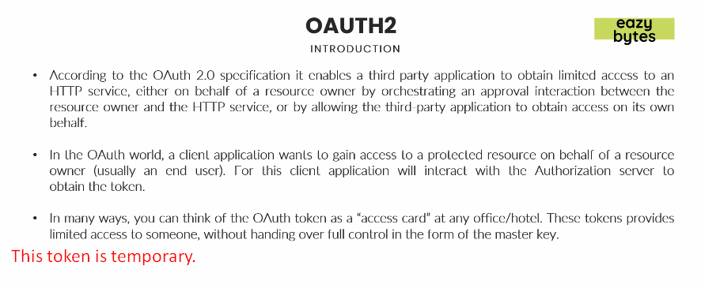
6. **Another Example for using Oauth Token**:
   1. Suppose, you’re doing registration on some web site where you have to enter your first name, last name, mobile# etc.
   2. Now, instead of entering those info which is a tedious job, you’re redirected to facebook where your these basic info are already there.
   3. So, facebook releases a token to the site using which the site accesses your those basic info.
7. As soon as the token is invalidated, the one having that token can’t access protected resources.